Huelgas Ensemble - Music from the Court of King Janus
Music from the Cypriot Manuscript Torino

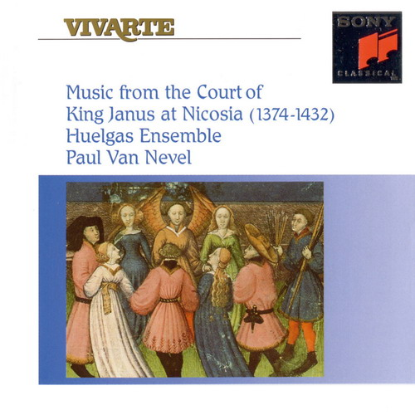


Former Cathedral of St. Sophia, now a mosque in the northern sector of Nicosia

В течение трех столетиe, начиная с 1192 года, остров Кипр был форпостом европеeскоe культуры. Но своего кульминационного момента развитие киприотскоe музыки достигло во время правлнения
Janus of Cyprus (1374-1432), когда на острове развивался собственныe стиль, весьма отличныe от европеeского, и хотя влияние Ars Subtilior нельзя отрицать, дополнительные элементы - чрезвычаeно сложные ритмы - подчеркивают национальные особенности. Непосредственно Джанусу мы обязаны знакомством с этим музыкальным наследием: его дочь Анна после брака с Луи, графом Женевским, увезла с собоe толстую рукопись (хранящуюся ныне в National Library of Turin, написанную между 1413 и 1426 годами, которая остается молчаливым свидетелем музыки, которую можно было услышать при дворе Никосии.

Medieval Music of Cyprus


Cover Painting: "Love Roundplay", from French book illustration, master of the "Roman de la Rose", c.1420-30; Archiv fur Kunst und Geschichte, Berlin

Contents:

1. Sanctus in eternis - Sanctus et ingenitus
2. Si doulchement mon ceur je sens souspris
3. Je sui trestout d'amour raimpli
4. Je prens d'amour noriture
5. Gloria
6. Certes mout fu - Nous devons tresfort amer
7. Je prens plaisir en une dame
8. Credo
9. Personet armonia
10. Si doulcement me fait amours - Nulz vrais amans

Playing time: 77'

Recorded at the Chapel of Abdij Marienlof, Belgium, June 16-18 1993

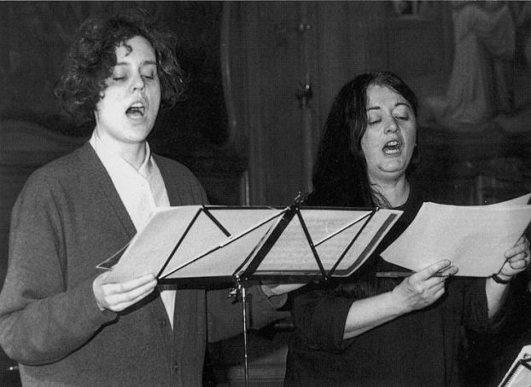
Katelijne Van Laethem ▪ Marie-Claude Vallin

Performer: Huelgas Ensemble

Katelijne Van Laethem, Marie-Claude Vallin, cantus
Marius Van Altena, Harry Van Berne, Otto Rastbichler, tenor
Willem Ceuleers, Harry Van der Kamp, bassus
An Van Laethem, fiddle,viella
René Van Laken, fiddle,viella
Bart Coen, recorders
Peter de Clercq, bass recorder
Harry Ries, sackbuts
Joost Swinkels, tenor sackbut

Paul Van Nevel, conductor

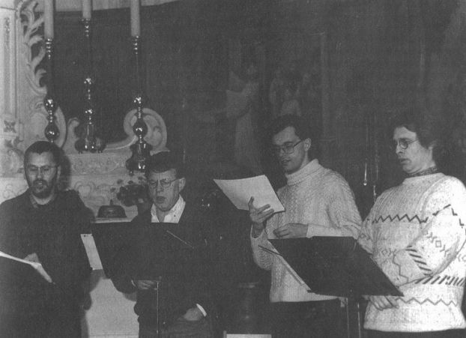
Otto Rastbichler ▪ Marius Van Altena ▪ Willem Ceuleers ▪ Harry Van der Kamp

Music from the Court of King Janus at Nicosia
Anonymous (Composer), Gregorian Chant (Composer), Research Composer (Composer), Paul van Nevel (Conductor), Huelgas Ensemble (Performer)

Product Details
- Composer: Anonymous, Gregorian Chant, Research Composer
- Conductor: Paul van Nevel
- Performer: Huelgas Ensemble
- Audio CD (May 3, 1994)
- SPARS Code: DDD
- Number of Discs: 1
- Label: Sony
- ASIN: B00000296S

1. Sanctus In eternis - Sanctus et ingenitus
2. Si doulchement mon ceur je sens souspris
3. Je sui trestout d'amour raimpli
4. Je prens d'amour noriture
5. Gloria
6. Certes mout fu - Nous devons tresfort amer
7. Je prens plaisir en une dame
8. Credo
9. Personet armonia
10. Si doulcement me fait amours - Nulz vrais amans

On this CD:
- Sanctus in eternis - Sanctus et ingenitus, four part isorhythmic motet (Folio 75 verso - 75 recto)
Composed by Research Composer
with Huelgas Ensemble
Conducted by Paul van Nevel
- Je sui trestout d'amour raimpli, three part virelai (Folio 155 recto)
Composed by Anonymous
with Huelgas Ensemble
Conducted by Paul van Nevel
- Je Prens D'Amour, virelai
Composed by Anonymous
with Huelgas Ensemble
Conducted by Paul van Nevel
- Gloria, for 4 voices
Composed by Anonymous
with Huelgas Ensemble
Conducted by Paul van Nevel
- Certes mout fu - Nous devons tresfort amer, four part isorhythmic motet (Folio 76 verso - 77 recto)
Composed by Anonymous
with Huelgas Ensemble
Conducted by Paul van Nevel
- Je prens plaisir en une dame, three part ballade (Folio 104 verso)
Composed by Anonymous
with Huelgas Ensemble
Conducted by Paul van Nevel
- Credo I
Composed by Gregorian Chant
with Huelgas Ensemble
Conducted by Paul van Nevel
- Personet armonia, three part isorhythmic motet, instrumental (Folio 71 verso - 72 recto)
Composed by Anonymous
with Huelgas Ensemble
Conducted by Paul van Nevel
- Si doulcement me fait amours - Nulz vrais amans, four part ballade double (Folio 127 recto, 127 verso)
Composed by Research Composer
with Huelgas Ensemble
Conducted by Paul van Nevel
CD: Huelgas Ensemble - Music from the Court of King Janus at Nicosia
Dir: Paul Van Nevel
(P)+(C) Sony Music
Sony Vivarte SK 53976

01. Sanctus in eternis - Sanctus et ingenitus [0:03:51.00]
02. Si doulchement mon ceur je sens souspris [0:05:42.37]
03. Je sui trestout d'amour raimpli [0:08:13.28]
04. Je prens d'amour noriture [0:07:26.02]
05. Gloria [0:04:34.40]
06. Certes mout fu - Nous devons trefort amer [0:05:36.35]
07. Je prens plaisir en une dame [0:10:22.10]
08. Credo [0:08:07.10]
09. Personet armonia [0:03:34.08]
10. Si doulcement me fait amour - Mulz vrais amans [0:19:19.20]

Performers: Katelijne Van Laethem, Marie-Claude Vallin, Marius Van Altena, Harry Van Berne, Otto Rastbichler, Willem Ceuleers, Harry Van der Kamp, An Van Laethem (fiddle), Rene Van Laken (fiddle, rebec), Bart Coen (recorders), Peter de Clercq (bass recorder), Harry Ries (sackbuts), Joost Swinkels (tenor sackbut)

Playing time: 77'
Recording date: June 1993

This recording is vocal and instrumental (winds and strings), and adopts an expansive treatment. It presents a cross-section of the many genres in the large Turin manuscript.

MUSIC FROM THE COURT OF KING JANUS AT NICOSIA (1374--1432). Paul van Nevel directing Huelgas Ensemble. SONY VIVARTE SK 53976 [DDD]; 76:45. Produced by Wolf Erichson.

ANON.: Sanctus. Si doulchement mon cuer. Je sui trestout. Je prens d'amour. Gloria. Certes mout fu. Je prens plaisir. Credo. Personet armonia. Si doulcement me fait amours.

While King Janus was hardly the most famous of the kings of Cyprus of the Lusignan dynasty, which governed the strategic island from 1192 to 1489, he reigned while the manuscript recorded here was written (between 1413 and 1426). It went to Savoy with his daughter as a dowry and ended up in the possession of the kings of Italy, who succeeded to the dynastic title after the last king of Cyprus died, leaving the island to the Venetian Republic. It is now Torino, B.N. J.II.9 (National Library at Turin). As might be expected of a French court at the turn of that century, it contains music of the Ars Subtilior, the transitional style between Machaut and the early Renaissance.

Music from this manuscript has recently been recorded by Ensemble P.A.N. (Fanfare 14:6, p. 354), but Paul van Nevel has been researching and recording it for many years. His first collection on Alpha (4:2, p. 204) was followed by the "O" antiphons from this manuscript, recorded first on Pavane and then remade on Deutsche Harmonia Mundi (a record I wanted to review but eventually had to purchase after having bought the Pavane LP in Belgium). The present disc duplicates Je sui tristout from the Alpha disc and two pieces from Ensemble P.A.N.; the Gloria and Credo on this disc are different than those on the Alpha disc.

The opening piece is Sanctus in eternis/Sanctus et ingenitus, a typically involved isorhythmic motet with two troped texts in the descant voices. The Credo is a curiously lilting isorhythmic movement, more interesting than the setting van Nevel recorded earlier. The Gloria, which forms a pair with it in the manuscript, is similar in its construction. The double ballade that he places last on the disc may be a favorite selection, for the melancholy love song is impressively sung.

The Ars Subtilior is a difficult period, and this disc can be recommended more to specialists than to casual listeners, but it repays close listening. The notes are detailed and texts are printed with translation.

J. F. Weber

THE LUSIGNAN DYNASTY - Decline
http://www.cypnet.com/.ncyprus/cyphistory/lusignan/4janus.htm

The Reign of Janus
Introduction

Jacques I died in 1398 and was succeeded by his son Janus.
The reign of King Janus for thirty-four years was one long struggle with the Genoese and the Moslems. His first object was to recover, if possible, Famagusta from the Genoese, whose power in Europe had begun to decline. With this object he prepared in 1402 a fleet and a force to besiege Famagusta. To defend it the Genoese sent a small fleet under the admiral, Bucciardo. Hostilities were ended by the mediation of the Grand Master of the Hospitallers and, after making peace, both parties directed their forces against the Moslems.

The Genoese ravaged the Syrian coast, while King Janus plundered the shores of Egypt. This drew upon Cyprus the vengeance of the Mamelukes, who were still seeking to retaliate for the sack of Alexandria by Pierre I. In the midst of war, Cyprus was for the third time attacked by plague, and the consequent weakness of the island gave the sultan the opportunity for which he had waited.

The Rule of Janus

In 1425 the Egyptian fleet appeared off the coast of Cyprus, defeated the Cypriot ships and plundered Larnaca and Limassol. The following year a still larger force seized Limassol and marched on Nicosia. King Janus, with all the forces he could muster, met the advancing Mamelukes at Chirokitia, where a battle took place on 7 July 1426. The Cypriot army was routed. King Janus was taken prisoner and most of the nobility were captured or slain. On the night of the battle, Hugues de Lusignan, brother of the king and Latin archbishop of Nicosia, left the capital with the royal family and took refuge in the castle of Kyrenia. On 11 July the city of Nicosia was sacked. The Mamelukes broke into every building, palace, and burnt the city, including the king's palace. The Mamelukes eventually retired with immense booty and numbers of prisoners, who were sold as slaves in Alexandria.
After a captivity of ten months King Janus was released on payment of an enormous ransom, the promise of an annual tribute to Egypt, and recognition of the suzerainty of the Sultan. During the king’s captivity the government of the island was carried on by his brother the archbishop, who had to put down a rising of the peasantry under an Italian, Sforza Pallavicino, who attempted to seize the government. King Janus returned broken in spirit and in fortune. He died in 1432, and with him ended the greatness of the Lusignan house.


Lala Mustafa Pasha Mosque - St Nicholas Cathedral
early music, medieval



Cypriot songs & motets
Music from the Court of King Janus at Nicosia (1374-1432)
Huelgas Ensemble - Paul Van Nevel
Sony Vivarte 53976

Contents:
- Sanctus in eternis / Sanctus et ingenitus (motet à 4)
- Si doulchement mon ceur je sens souspris (ballade à 3)
- Je sui trestout d'amour raimpli (virelai à 3)
- Je prens da'mour noriture (instrumental virelai à 3)
- Gloria à 4
- Certes mout fu / Nous devons tresfort amer (motet à 4)
- Je prens plaisir en une dame (ballade à 3)
- Credo à 4
- Personet armonia (instrumental motet à 5)
- Si doulcement me fait amours / Nulz vrais amans (double ballade à 4)
Performers: Katelijne Van Laethem, Marie-Claude Vallin, Marius Van Altena, Harry Van Berne, Otto Rastbichler, Willem Ceuleers, Harry Van der Kamp, An Van Laethem (fiddle), René Van Laken (fiddle, rebec), Bart Coen (recorders), Peter de Clercq (bass recorder), Harry Ries (sackbuts), Joost Swinkels (tenor sackbut)
Playing time: 77'
Recording date: June 1993
This recording is vocal and instrumental (winds and strings), and adopts an expansive treatment. It presents a cross-section of the many genres in the large Turin manuscript. Another recording, focusing on a specific part of the manuscript:
Cypriot Advent Antiphons
Anonymous c.1390
Huelgas Ensemble - Paul Van Nevel
Deutsche Harmonia Mundi 7977
The Cypriot Advent Antiphons are the famous cycle of "O"-Antiphons, the most elaborate liturgical pieces in the manuscript.
The Huelgas Ensemble's other Ars Subtilior recordings on CD:
Febus Avant!
Music at the Court of Gaston Febus (1331-1391)
Huelgas Ensemble - Paul Van Nevel
Sony Vivarte 48195
Perusio: Virelais, Ballades, Caccia
Huelgas Ensemble - Paul Van Nevel
Sony Vivarte 62928
Ciconia: Oeuvre intégrale
Huelgas Ensemble - Paul Van Nevel
Pavane 7345/7 (3 CDs)
Finally, some other recordings devoted to the Turin manuscript:
Flour de Beaulté
Late Medieval Songs From Cyprus
La Morra - Michal Gondko & Corina Marti
Ramée 0602
The Island of St. Hylarion
Music of Cyprus: 1413-1422
Ensemble Project Ars Nova
New Albion 038
La Polyphonie à la Cour de Chypre (vers 1420)
Les Paraphonistes de Saint-Jean-des-Matines - Guillaume de Van
L'Anthologie sonore 126 (78rpm)
To purchasing information for this disc.
To FAQ references to this recording.
To FAQ CD index page.
Todd M. McComb

