UTOPIA TRIUMPHANS - Huelgas Ensemble - Paul Van Nevel
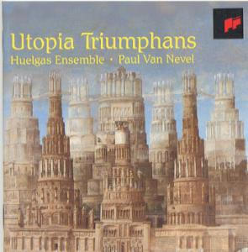

UTOPIA TRIUMPHANS The Great Polyphony of the Renaissance
(Thomas TALLIS, Josquin DESPREZ, Johannes OCKEGHEM, Pierre de MANCHICOURT, Giovanni GABRIELLI...)
Huelgas Ensemble
dir : Paul Van Nevel
Recorded at St. Barbara Church, Gent, Belgium, September 9 &10, 1994
DDD TT: 52:46
Contents:

1 Thomas Tallis: Spem in alium (à 40)
2 Costanzo Porta: Sanctus (à 13) / Agnus Dei (à 14)
3 Josquin Desprez: Qui habitat (à 24)
4 Johannes Ockeghem: Deo gratias (à 36)
5 Pierre de Manchicourt: Laudate Dominum (à 6)
6 Giovanni Gabrieli: Exaudi me Domine (à 16)
7 Alessandro Striggio: Ecce beatam lucem (à 40)

Utopia Triumphans
Huelgas Ensemble (Artist), Paul Van Nevel (Artist), Thomas Tallis (Artist), Costanzo Porta (Artist), Josquin Desprez (Artist), Johannes Ockeghem (Artist), Pierre de Manchicourt (Artist), Giovanni Gabrieli (Artist), Allesandro Striggio (Artist)

Utopia Triumphans
Utopia Triumphans
The Great Polyphony of the Renaissance
Huelgas Ensemble - Paul Van Nevel
Sony Vivarte 66261

Contents:
- Thomas Tallis: Spem in alium (à 40)
- Costanzo Porta: Sanctus (à 13) / Agnus Dei (à 14)
- Josquin Desprez: Qui habitat (à 24)
- Johannes Ockeghem: Deo gratias (à 36)
- Pierre de Manchicourt: Laudate Dominum (à 6)
- Giovanni Gabrieli: Exaudi me Domine (à 16)
- Alessandro Striggio: Ecce beatam lucem (à 40)
Performers: Superius: Barbara Borden, Annemie Buyle, Cathérine Joussellin, Uta Kirsten-Went, Marie-Claude Vallin, Dineke van der Sman, Ellen van Ham, Francisca Van Herle, Lize van Jaarsfeld, Els Van Laethem, Machteld van Woerden; Altus: Peter de Groot, Irene Heuvelmans, Brigitte Le Baron, Cecilia Roovers, Consuelo Sanudo, Arno Tabertshofer; Tenor: Christopher Kale, Lucien Kandel, Eric Mentzel, Philip Pooley, Jasper Schweppe, Eitan Sorek, Lieven Termont, Marius van Altena, Harry van Berne, Marc Van Daele, Stéphane van Dijck, Ibo van Ingen, Sjef van Leunen, Matthew Vine, John Vredeveldt; Bassus: Conor Biggs, Job Boswinkel, Willem Ceuleers, Lieven Deroo, Herman De Winné, Erik Hermans, Paul Mertens, Mitchell Sandler, Dirk Snellings, Dirk Van Croonenborch, Harry van der Kamp
Playing time: 53'
Recording date: September 1994
This recording features several of the largest scale (by number of parts) compositions of the Renaissance. Of course, Tallis' 40-part motet is the best-known. Alessandro Striggio (c.1535-1592) was apparently the inspiration for Tallis' 40-part motet, bringing his own such piece to England in 1567. Tallis was prompted to compose an English "reply."
The Huelgas Ensemble uncharacteristically performs all of these pieces without instrumental support, and indeed sings them standing in a circle. The effect can be very pleasing over good audio equipment.
Costanzo Porta (c.1529-1601) left a huge body of music, written largely in the style of Costanzo Festa (c.1490-1545). The selected excerpts are from his Missa Ducalis.
A recording devoted to Porta:
Porta: Madrigali / Motetti / Missa quatuor vocum
Ensemble Les Nations - Maria Luisa Baldassari / Ensemble Speculum Musicae - Marina Malavasi
Tactus 524101
The more modest 6-part motet of Pierre de Manchicourt (c.1510-1564) is recorded with two singers to a part.
Of course, Josquin, Ockeghem & Gabrieli are well-known. Josquin's motet is a setting of Psalm 90, and rather unique in his output. The 36-voice Deo gratias attributed to Ockeghem is actually a strict canon; whereas the attribution does date to the Renaissance itself, it remains highly dubious.
Another recording of large-scale Renaissance vocal music by the present ensemble:
Padovano: Messe à 24 voix
Huelgas Ensemble - Paul Van Nevel
Harmonia Mundi 901727
To purchasing information for this disc
To page of FAQ citation for this disc
Todd M. McComb

Huelgas Ensemble - Utopia Triumphans
The Great Polyphony of the Renaissance

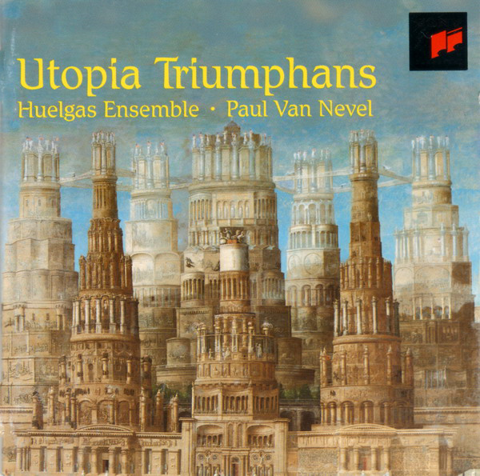

Утопия у власти... Самые известные полифонические произведения эпохи Возрождения.
В их числе знаменитый 40-голосный мотет "Spem in alium" Томаса Таллиса.

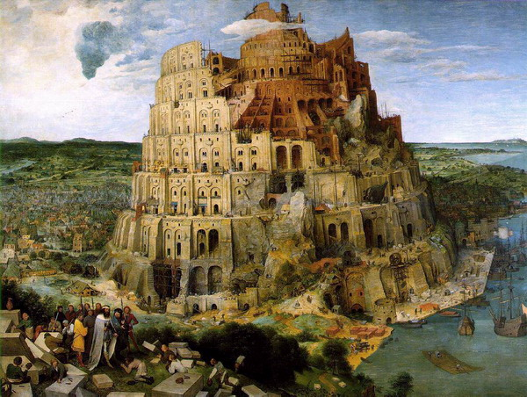
Питер Брейгель Старший - Вавилонская башня, 1563

Contents:

1. Thomas Tallis: Spem in alium (à 40 voix)
2. Costanzo Porta: Sanctus (à 13 voix) / Agnus Dei (à 14 voix) - from "Missa Ducalis"
3. Josquin Desprez: Qui habitat (à 24 voix)
4. Johannes Ockeghem: Deo gratias (à 36 voix)
5. Pierre de Manchicourt: Laudate Dominum (à 6 voix)
6. Giovanni Gabrieli: Exaudi me Domine (à 16 voix)
7. Alessandro Striggio: Ecce beatam lucem (à 40 voix)

Playing time: 53'

Recorded at St. Barbara Churhh, Gent, Belgium, September 9 & 10, 1994

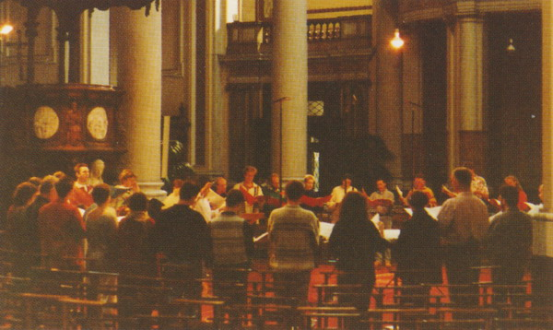

Performer: Huelgas Ensemble

Superius: Barbara Borden, Annemie Buyle, Cathérine Joussellin, Uta Kirsten-Went, Marie-Claude Vallin, Dineke van der Sman, Ellen van Ham, Francisca Van Herle, Lize van Jaarsfeld, Els Van Laethem, Machteld van Woerden
Altus: Peter de Groot, Irene Heuvelmans, Brigitte Le Baron, Cecilia Roovers, Consuelo Sanudo, Arno Tabertshofer
Tenor: Christopher Kale, Lucien Kandel, Eric Mentzel, Philip Pooley, Jasper Schweppe, Eitan Sorek, Lieven Termont, Marius van Altena, Harry van Berne, Marc Van Daele, Stéphane van Dijck, Ibo van Ingen, Sjef van Leunen, Matthew Vine, John Vredeveldt
Bassus: Conor Biggs, Job Boswinkel, Willem Ceuleers, Lieven Deroo, Herman De Winné, Erik Hermans, Paul Mertens, Mitchell Sandler, Dirk Snellings, Dirk Van Croonenborch, Harry van der Kamp

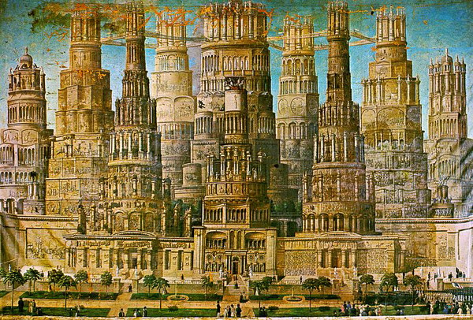
Cover Painting: Erastus Salisbary Field (1805 - 1900): Historic Monument of the American Republic, 1800s.

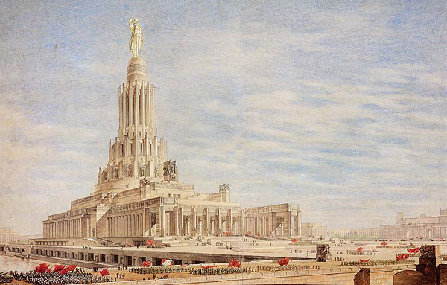
Дворец Cоветов. Б. Иофан, В. Гельфрейх, Я.Белопольский, В. Пелевин. Скульптор С. Меркулов.
Один из вариантов утвержденного проекта. 1946 © МУАР
renaissance, early music, medieval

Utopia Triumphans
The Great Polyphony of the Renaissance
Thomas Tallis (c.1505-1585)
Constanzo Porta (c.1529-1601)
Josquin Desprez (c.1440-1521)
Johannes Ockeghem (c.1410-1497)
Pierre de Manchicourt (c.1510-1564)
Giovanni Gabrielli (c.1553-1612)
Alessandro Striggio (c.1535-1592)
Huelgas Ensemble
Paul Van Nevel, conductor
Recording : St. Barbara Church, Gent, Belgium, September 9 & 10,1994

