Costanzo Festa - "La Spagna" - 32 Contrapunti  
*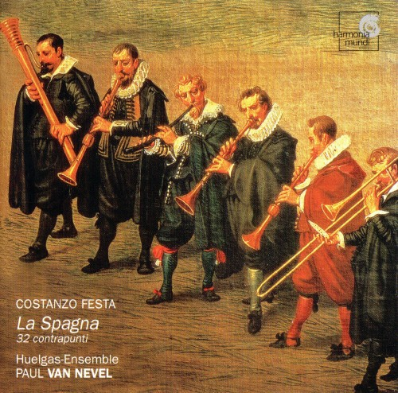*

Жанр: Classical  
Страна-производитель диска: Made in Germany  
Год издания диска: 2003  
Издатель (лейбл): Harmonia Mundi Fr.  
Номер по каталогу: HMC 801799  
Дата записи: 2002  
Аудиокодек: FLAC  
Тип рипа: image+.cue  
Битрейт аудио: lossless  
Продолжительность: 52:08  
Источник: релизер  
сайт-источник/ник/другое: Orlando.Furioso meeting music, подарок  
Наличие сканов в содержимом раздачи: да

Треклист

1 Contrapunto 46 à 4 - Première et deuxième voix basées sur ré-mi-fa-sol  
2 Contrapunto 41 à 4 - Contrepoint libre, la structure harmonique est plus particulièrement mise en évidence  
3 Contrapunto 105 à 5 - La voix supérieure repose sur le motif la-sol-mi-fa-sol-la, avec une variation rythmique  
4 Contrapunto 101 à 4 - La deuxième voix paraphrase le madrigal "Ahi dispietato tempo"  
5 Contrapunto 88 à 4 - Chacune des voix est associée à une valeur rythmique  
6 Contrapunto 76 à 4 - La deuxième voix repose exclusivement sur le motif ut-ré-mi et fa-sol-la, avec une variation rythmique  
7 Contrapunto 124 à 8 - Contrepoint en imitation  
8 Contrapunto 81 à 4 - Canon en unisson à la deuxième voix inférieure  
9 Contrapunto 60 à 4 - Contrepoint en imitation dans le grave  
10 Contrapunto 77 à 4 - Contrepoint coloré en imitation  
11 Contrapunto 122 à 7 - La première voix reprend exclusivement un la  
12 Contrapunto 25 à 4 - Contrepoint en imitation  
13 Contrapunto 118 à 5  
14 Contrapunto 47 à 4 - Motif en ostinato sur sol-sol-sol-mi-fa-sol aux autres voix  
15 Contrapunto 35 à 4 - Contrepoint en imitation  
16 Contrapunto 40 à 4 - A quatre voix égales  
17 Contrapunto 8 à 3  
18 Contrapunto 14 à 3 - En mesure ternaire  
19 Contrapunto 108 à 5 - Contrepoint très lent constitué d'un canon double  
20 Contrapunto 9 à 3 - Contrepoint ornementé en imitation  
21 Contrapunto 85 à 4 - Contrepoint libre avec des syncopatio particulièrement nombreaux  
22 Contrapunto 37 à 4 - Première voix en ostinatio  
23 Contrapunto 70 à 4  
24 Contrapunto 125 à 11 - La dernière variation du manuscrit  
25 Contrapunto 71 à 4 - Canon inversé entre la première et la quatrième voix  
26 Contrapunto 117 à 5  
27 Contrapunto 28 à 4 - Ostinato à la basse  
28 Contrapunto 104 à 5 - Première et quatrième voix en soggetto cavato  
29 Contrapunto 58 à 4 - Contrepoint en imitation dans le grave  
30 Contrapunto 121 à 6 - La plus longue variation de toutes; chaque note du cantus firmus dure trois brevis  
31 Contrapunto 123 à 8 - Canon triple, souvent à l'unisson  
32 Contrapunto 34 à 4 - Première voix sur la-sol-fa en ostinato

Исполнители

Costanzo Festa (ca. 1490-1545)  
Huelgas Ensemble  
Conductor: Paul van Nevel  
Performers:  
Bart Coen Peter de Ciercq, Baldrick Deerenberg, Koen Dieltiens (recorders);  
Beátrice Delpierre, Mirella Ruigrok, Michéle Van den Broucque (dulcians);  
Björk Frithof Smith (cornett);  
Wim Becu, Dominique Lortie, Joost Swinkels, Simen Van Mechelen (sackbutts);  
An Van Laetham (Renaissance violin);  
Kristina Kyprianides, Piet Strijckers, Paulina Van Laarhoven (viols);  
Matthieu Lusson (violone).  
Recording date: June 2002  
Audio CD (December 9, 2003)

Доп. информация

Amazon.com  
This is a strange but rewarding undertaking. It presents 23 of the 125 variations Costanzo Festa (ca. 1490-1545) composed based on the 37-note "cantus firmus" (fixed melody or, simply, tune) which was known, in the 15th century, as "La Spagna." Despite the obvious, necessary sameness of the material, the variety of instruments involved keeps the sound fresh and the ear engaged. They range in timings from a miniature 50 seconds to a more developed 3:47. One might suspect that these are insubstantial, but the instrumentation and tempi make for a nice complexity. Only one is for mixed singing voices; others are for wind instruments (flutes and dulcians), brass, strings, and combinations thereof. This fits into no category (the accompanying notes compare it to Bach's Goldberg Variations, but the latter are scored for one instrument and so the evaluation fails), yet it's bound to fascinate. It's easy to listen to, and the result is a wonderful palette of colors more notable for thier differences--primary, pastel, bright, dark--than thier likenesses; some of the variations pop to the forefront while others become a mellow background. The performances, by a group of virtuosi, are superb, the sonics ideal. Recommended. --Robert Levine

Доп. информация II

Festa's monumental set of 125 "contrapunti," or variations, on the "La Spagna" theme, was never published, and, though occasionally mentioned by later theorists, was largely forgotten after his death. These variations survive in a manuscript of one hundred, fifty-seven contrapunti on the La Spagna theme and are there attributed to Giovanni Maria Nanino (1545-1607). It has been established that the first one hundred, twenty-five of these contrapunti are in fact by Festa, the rest being Nanino's work. The wealth of invention in these works is astounding, the more so because Festa has each contrapunto begin with the first note of the theme and end with the last, and employs some portion of the theme in every intervening bar. Fully one hundred, twenty-one contrapunti also retain the thirty-seven bar length of the original theme. Festa uses a variety of techniques in composing counterpoint, including canon, ostinato, borrowing (from Josquin's "La sol fa re mi" theme and various Italian madrigals), imitation, and soggetto cavato (the use of Guidonian solfege syllables to turn words into notes; in contrapunto 104, the names of Isabella and Ferdinand, rulers of Spain, are so treated). Comparison is made to Bach's Goldberg Variations, although, if the present recording is any indication of the length of the rest of the work, Festa's opus is slightly more than three times as long as Bach's. Voices are employed on some tracks (e.g., track 28), but in general the works are given a purely instrumental rendition.  
Paul Van Nevel's subtitles are given in French italics above. The music probably dates to the 1530s.