**Huelgas Ensemble - The Mirror of Claudio Monteverdi (2016) [Hi-Res]**

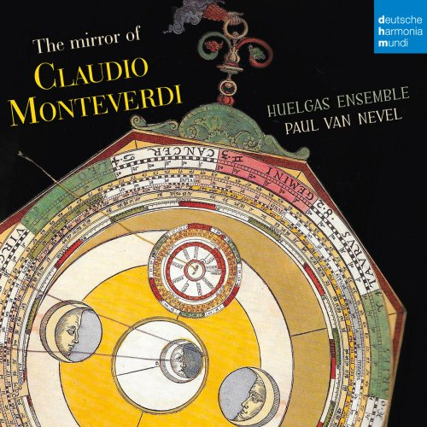

**Artist**: Huelgas Ensemble  
**Title**: The Mirror of Claudio Monteverdi  
**Year Of Release**: 2016  
**Label**: deutsche harmonia mundi  
**Genre**: Classical  
**Total Time**: 00:59:12  
**WebSite**: [Album Preview](https://www.7digital.com/artist/huelgas-ensemble/release/the-mirror-of-claudio-monteverdi-5918130)

**Tracklist**  
---------  
01. Missa in illo tempore, SV 205: I. Kyrie  
02. Laura che'l verde lauro  
03. Missa in illo tempore, SV 205: II. Gloria  
04. Amor  
05. Missa in illo tempore, SV 205: III. Credo  
06. Mia benigna fortuna  
07. Missa in illo tempore, SV 205: IV. Sanctus  
08. Solo e pensoso  
09. Missa in illo tempore, SV 205: V. Agnus Dei  
  
The Huelgas Ensemble, directed by its founder Paul van Nevel, began as the result of a previous generation's work in early music performance, led by, among others, Thomas Binkley and David Munrow. Remarkably, after more than 30 years, the ensemble retains a sense of excitement, innovation and discovery, long after the mass recording industry and the new age movement co-opted the esoteric sounds of the Middle Ages and Renaissance. When van Nevel, active at the Schola Cantorum Basilensis, founded the ensemble in 1971, a rediscovered instrumentarium of cornettos, sackbuts, recorders, and crumhorns were being jubilantly applied to early music performances. The Huelgas Ensemble then sat at the center of the movement toward "authentic" performance practices, and its interpretations were strongly influential. As the scholarly and performative norms for Medieval music have changed, so has the sound of Huelgas, most prominently depicted in its increased vocalizations. But the ensemble has retained a mantle of eccentricity and innovation.  
  
Nearly every aspect of director van Nevel's performances has been subject to experimentation over his career. From the group's inception, reliable and evocative ornamentation was a goal for both instrumentalists and singers. The ensemble constantly upsets expectations through scoring and orchestration. A 1994 program of Music for King Janus of Nicosia presents some pieces at half or less the expected tempo, losing the text, but richly extending the pungency of dissonances. In the same year, Huelgas released a recording of the Lassus Lagrime di San Pietro juxtaposed with a performance by an all-vocal ensemble led by Philippe Herreweghe. A 1999 recording dedicated to Alexander Agricola includes some striking chromatic manipulations of the so-called "Secret Chromatic Art." At all times, Paul van Nevel's approach to his repertory has been fearlessly innovative, despite criticism both from scholars and from other performers.  
  
Another area of van Nevel's musical boldness, that of musical repertory, has been perhaps the ensemble's greatest contribution to our musical world. The director's scholarly interests lead him toward little-known manuscripts -- the Turin manuscript (1985), the Naples collection of L'Homme Armé Masses (1990), the Huelgas Codex (1999) -- and less-appreciated composers -- Gombert (1993), Constanzo Festa (1994), Mattheus Pipelare (1996), Pierre de Manchicourt (1998), Matteo da Perugia (1998), and Alexander Agricola (1999). The Huelgas Ensemble brought out the only "complete works" recording of Johannes Ciconia as early as 1982, has given world-premiere recording of the Brumel "Earthquake" Mass, and undertook a fascinating collaboration with the Portuguese singers of Fado called Tears of Lisbon. In each case, the lively and compelling performances have stretched musical boundaries.

Le principe de cet album de l’excellent Ensemble Huelgas est de présenter les cinq numéros de la Missa in illo tempore à six voix de Monteverdi encadrant quatre œuvres plus anciennes de quatre autres compositeurs – Vicentino, Tudino, de Wert et Marenzio –, plus anciennes et pourtant plus « progressistes » ! Cela dit, il ne faut pas forcément s’étonner que la Messe de Monteverdi, publiée en 1610, sonne plus « ancienne » puisque le compositeur lui-même l’avait délibérément conçue dans le style polyphonique du XVIe siècle d’après Gombert, dans une écriture en partie parodique (parodique dans le sens musicologique du terme : il ne s’agit donc pas de se moquer de quiconque, mais d’user d’emprunts et de citations, para-odia qui, par contraction, devient parodie). Les quatre motets des collègues, tous plus anciens au moins d’une génération, repoussent toutes les frontières harmoniques et mélodiques avec usage de hardis chromatismes que n’aurait pas reniés un Gesualdo, ce qui n’est pas peu dire. Précisons que l’Ensemble Huelgas, malgré son nom, n’est pas du tout espagnol mais tout simplement belge ; le nom, d’ailleurs, ne signifie pas « grève » ou « protestation » selon le mot espagnol, mais reprend le titre du codex Las Huelgas, un manuscrit médiéval cistercien contenant quelque deux cents œuvres musicales fondamentales pour la compréhension de l’art de cette époque.