Morimur
Johann Sebastian Bach (Composer), countertenor David James (Performer), violin Christoph Poppen (Performer), soprano Monika Mauch (Performer), tenor John Potter (Performer), Hilliard Ensemble (Performer), baritone Gordon Jones (Performer)

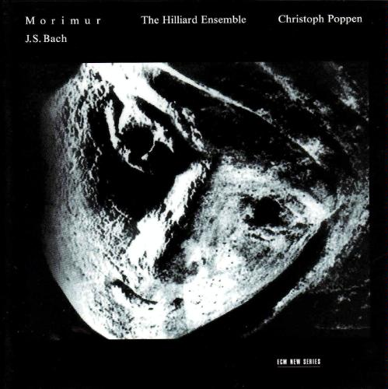

Product Details
- Composer: Johann Sebastian Bach
- Performer: countertenor David James, violin Christoph Poppen, soprano Monika Mauch, tenor John Potter, Hilliard Ensemble, et al.
- Audio CD (September 25, 2001)
- SPARS Code: DDD
- Number of Discs: 1
- Label: ECM Records
- ASIN: B00005ND3J

On this CD:
- Cantata No. 136, "Erforsche mich, Gott, und erfahre mein Herz," BWV 136 (BC A111) Chorale for 4 voices "Auf meinen lieben Gott"
Composed by Johann Sebastian Bach
with Hilliard Ensemble, Christoph Poppen
- Christ lag in Todes Banden (II), chorale setting for 4 voices, BWV 278 (BC F26.2) Den Tod..., single voice excerpt
Composed by Johann Sebastian Bach
with David James
- Partita for solo violin No. 2 in D minor, BWV 1004 Allemanda
Composed by Johann Sebastian Bach
with Christoph Poppen
- Christ lag in Todes Banden (I), chorale setting for 4 voices, BWV 277 (BC F26.1)
Composed by Johann Sebastian Bach
with Hilliard Ensemble
- Partita for solo violin No. 2 in D minor, BWV 1004 Corrente
Composed by Johann Sebastian Bach
with Christoph Poppen
- Christ lag in Todes Banden (II), chorale setting for 4 voices, BWV 278 (BC F26.2)
Composed by Johann Sebastian Bach
with Hilliard Ensemble
- Partita for solo violin No. 2 in D minor, BWV 1004 Sarabanda
Composed by Johann Sebastian Bach
with Christoph Poppen
- Cantata No. 188, "Ich habe meine Zuversicht," BWV 188 (BC A154) Chorale for 4 voices Text: "Wo soll ich fliehen hin"
Composed by Johann Sebastian Bach
with Hilliard Ensemble
- Partita for solo violin No. 2 in D minor, BWV 1004 Giga
Composed by Johann Sebastian Bach
with Christoph Poppen
- Christ lag in Todes Banden (II), chorale setting for 4 voices, BWV 278 (BC F26.2) Den Tod..., single voice excerpt
Composed by Johann Sebastian Bach
with David James
- Partita for solo violin No. 2 in D minor, BWV 1004 Ciaccona
Composed by Johann Sebastian Bach
- Christ lag in Todes Banden (I), chorale setting for 4 voices, BWV 277 (BC F26.1)
Composed by Johann Sebastian Bach
with Hilliard Ensemble
- St. John Passion (Johannespassion), BWV 245 (BC D2) Chorale for 4 voices "Dein Will gescheh'"
Composed by Johann Sebastian Bach
with Hilliard Ensemble
- Befiehl du deine Wege (I), chorale setting for 4 voices, BWV 270 (BC 92.1)
Composed by Johann Sebastian Bach
with Hilliard Ensemble
- Jesu, meine Freude, chorale setting for 4 voices, BWV 358 (BC F116)
Composed by Johann Sebastian Bach
with Hilliard Ensemble
- Cantata No. 188, "Ich habe meine Zuversicht," BWV 188 (BC A154) Chorale for 4 voices "Auf meinen lieben Gott"
Composed by Johann Sebastian Bach
with Hilliard Ensemble
- Cantata No. 5 "Wo soll ich fliehen hin," BWV 5 (BC A145) Chorale for 4 voices "Jesu Deine Passion"
Composed by Johann Sebastian Bach
with Hilliard Ensemble
- St. John Passion (Johannespassion), BWV 245 (BC D2) Chorale for 4 voices "In meines Herzens Grunde"
Composed by Johann Sebastian Bach
with Hilliard Ensemble
- Nun lob, mein Seel, den Herren (I), chorale setting for 4 voices, BWV 389 (BC F153.1)
Composed by Johann Sebastian Bach
with Hilliard Ensemble
- Christ lag in Todes Banden (II), chorale setting for 4 voices, BWV 278 (BC F26.2) Den Tod..., single voice excerpt
Composed by Johann Sebastian Bach
with David James
- Partita for solo violin No. 2 in D minor, BWV 1004 Ciaccona, accompanied by chorale fragments
Composed by Johann Sebastian Bach
with Hilliard Ensemble, Christoph Poppen
- Christ lag in Todes Banden (II), chorale setting for 4 voices, BWV 278 (BC F26.2) Den Tod..., single voice excerpt
Composed by Johann Sebastian Bach
with David James

